|  |
| --- |
| Introduction to Interaction Design |
| Diabetes Tracking App |
| Part Three - Design |

|  |
| --- |
| Amelia Chin, Nolan Mushtuk, and Femi Atunnise  12-1-2018 |

# DT App

# Introduction

Part 3 of the project proposal focuses on designing an interactive prototype using design patterns and UI elements for our new diabetic tracker app based on the requirements developed in part 2. The designs patterns and UI patterns play an important part in helping the user understand what goes on in the prototype because they will be similar to what the user has already experienced prior to this new system.

There are 2 current systems in place that are used to assist those diagnosed with diabetes with their tracking activities. The first is the pen and paper which is simple, reliable and allows the user to keep track in any form that want; however, some of the disadvantages are error-prone, inefficient, can be easily lost, damaged, and requires a lot of storage space. The second current system is the variety of apps provided for by the app store and/or google play store and these apps are very convenient for the users because the apps are on their mobile devices and they can input the data at any time. However, the disadvantages to this system is that some are too complex to learn or do not provide a lot of options. Another problem is that the screens within the apps can be too cluttered with data and buttons which can cause a lot of confusion when the user wants to complete a task. These problems are solved by presenting an app with familiar design patterns and UI elements to help diabetics navigate easily and manage their tracking easily with the use of a mobile device which can be used anywhere without any extra required materials.

# Problem

Thanks to an interview with Suzanne Justice about her struggle with the condition, and much searching online, we found that for many with diabetes, managing their condition is a hassle. The constant need to take blood readings and document them alongside their meal habits is time consuming and demoralizing. Many still use the tradition pen and paper method of documentation, but paper is easily lost or damaged, slow to scan over, piles up, and just plain boring; And all of that is if the person even remembers or cares enough to make the record. Current applications on the market to solve this problem are only somewhat effective, either too cluttered and difficult to understand or use or just not what someone with diabetes actually needs.

This application aims to simplify the lives of those managing diabetes with a pleasurable and straightforward interface to document their results either manually or automatically with an external device and to easily find any previous records they have made and allowing them to create doctor friendly reports or even share their results and trends with friends or support groups on social media.

The primary goal of someone who would use this application is to be as consistent and accurate as they can with their documentation so that they can live a healthier happier life. To allow this, the application satisfies their needs of easily monitoring their levels, reminding them to take readings, and notifying them of any irregularities in a timely manner. All their information will be stored and backed up from the device so that it is never hard to find. Motivation is also a major part of keeping consistent, so the system aims to provide meaningful feedback based on trends and provide small motivating rewards for being responsible.

# Design Decisions

By allowing the linking of an external reading device, the system can eliminate inaccurate readings and automatically inform the user when their levels get too high or low. A general reminder system is included as well that the user can set to remind them when to take readings or to remind them to document their nutrition intake.

Thanks to what we learned from our interview with Suzanne Justice we decided that system will have a fully customizable trends screen which conveniently shows current data and trends over an adjustable time period and staying within optimal ranges for time periods will give simple compliments as a motivation feature.

It was found when comparing similar products that others tend to be far too cluttered and formal, with little personalization or meaningful features, making it difficult to read and hard to use. The aim of this system is to be streamlined and easy for the user to understand

# Task Flow

A task flow is a single flow that’s based off on an explicit action that should completed similarly by all users, it is a linear flow that doesn’t branch out and it goes in on direction. It helps in understanding the goal of the system, in this case the diabetes tracking app. It also helps in knowing who the intended users and the users would go about using the system. A task flow starts with a trigger and then the step-by-step process that users are required to complete before getting to the successful outcome.

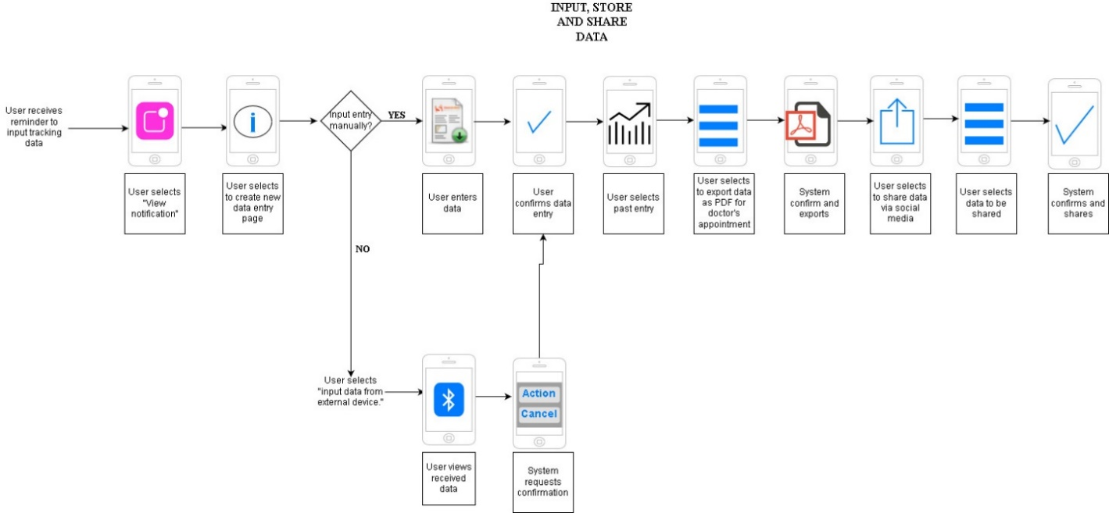

# Interactive Wireframe using Balsamiq

The interactive wireframe is a graphic structure of the app containing the content and elements. It is like a blueprint of application that shows the user navigating and interacting with the various elements on each screen. The wireframe is simple and acts as a stepping stone for designers at a later stage. It is also known as the low-fidelity that contains the main information, draws outline of the structure and handles the visual and description of the user interface.

# Hi fidelity Prototype

The hi-fidelity prototype is a computer-based interactive representation of the product in its closest resemblance to the final design in terms of details and functionality. It covers not only the visual representation of the app but also the user experience aspects in terms of interactions, user flow and behaviour. It considers what the user would like to see from the application and provides a solution for their problems. By using design patterns and interactive UI elements, the prototype is designed to provide a solution to the user’s goals, needs and wants.

<https://cloud.indigo.design/share/run/j85n58ebpwfz>

Screencast walkthrough

A screencast walkthrough utilizes a screen recording tool to record a walk-through of the hi-fidelity prototype, more specifically our myDiabetes app. A screencast walkthrough introduces the viewer to the scenario and provides a narration on each screen describing the functionalities that it provides for the user as well as any further features.

Design Patterns

A design pattern is a formal way of documenting a solution to a common commonly occurring usability problem in digital interaction design. The UI navigation elements that the prototype includes are the buttons to direct the user to a new screen (e.g. add entry button, convert to PDF version button, share on Facebook, etc…), and the back button to go back a screen. The orientation of the interactable buttons are placed so that it does not make the screen look cluttered. For example, the add entry button is located on the bottom right of the homepage and should stay there as the user scrolls through the homepage. This is to provide a quick and easy access to creating a new entry log without intruding the data space on the homepage. Another example is the back button which are in the top left of each screens. Most people are familiar with the orientation of the back button to be located at the top left side.

**Design pattern #1  
Name**: Logbook quick view (mini)  
**Description**: This is a mini version of the logbook screen located at the home page of the app. It provides a quick view of the most recent logs and a small summary of the important details within each of the logs (based on daily results). A key feature of this design is that the contents presented are similar to how the contents in an email are portrayed. This was chosen because a majority, if not all, of people are familiar with the way the email’s contents are presented. Another key feature is the small button “See more” provided. By using business sites like amazon and ebay as reference for this design decision, is purpose is to direct the user to a screen with more log results. In other words, it provides a shortcut to the actual logbook screen containing all the saved logs.  
**Problem addressed and solution:** The problem that this pattern addresses is the need to view recent logs without having navigate through the app. Mainly for convenience. The problem with navigating the app to search for a log that a user recently have made is that it is time consuming and can be tedious to do. Therefore, the logbook quick view provides a quick and easy view located on the homepage of the app so it is there when the user opens the app.   
**Link to an example:** <https://www.amazon.ca/>  
**Extra images to provide context to description:**

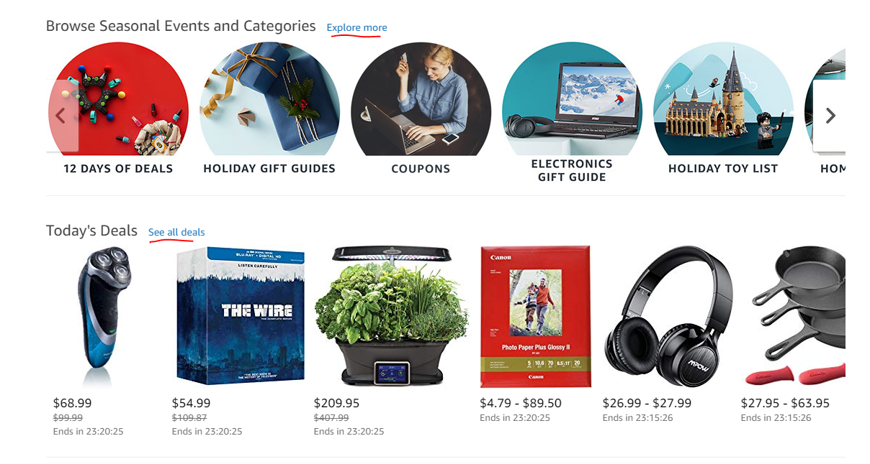from amazon

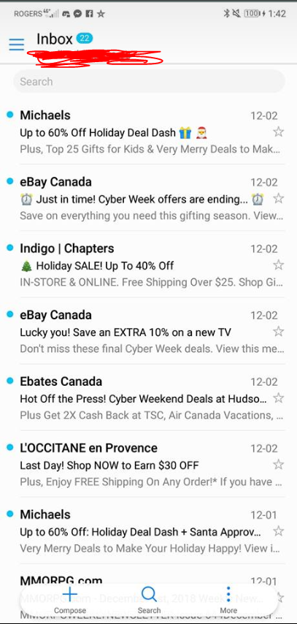 from email.

**Design pattern #2**  
**Name:** Add new entry button located on bottom right on homepage.  
**Description**: This is a button used to create a new log entry and should always be located at the bottom right even when the user scrolls through the homepage. It replaces the awkwardly placed icon located somewhere on the homepage or in the hamburger menu and provides for a quick access to create a new log input when the user first opens the app. For reference, gmail mobile app was used as well as the mySugr diabetes app.   
**Problem addressed and solution**: The problem that this design pattern addresses is the cluttered screen and difficult navigation of the application. Because the new entry button is located at the bottom right of the homepage, the user can easily access the new entry log upon entering the app without having to search for it.  
**Link to example:** None but I will provide images.  
**Extra images:**

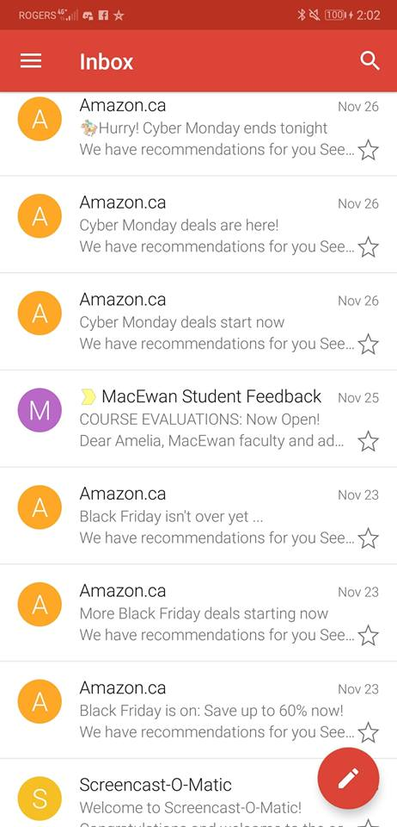from gmail mobile app.

**Design pattern #3**  
**Name:** Notification bell  
**Description**: This is a button located on the homepage. Once clicked, it will display notifications sent by the app in a drop-down overlay. For the first reference, Facebook notifications was used because they display their notifications on the top right of the news feed page (the first page that the users will see once they open up Facebook). Another reference is the YouTube site and how they also display their notification at the top right of their main home page. This design was chosen because a lot of people, young and old, are familiar with this style of notification system and it provides for convenience.   
Another thing that this drop-down overlay is designed to provide is a direct access to the notification system management screen by allowing the user to “add” a new notification. It also provides a feature to delete any notifications displayed on that overlay. I have not created the notification system management screen because it was not part of the flow, but what I had in mind was that this would provide a convenient alternative than having to search for the notification system management within the menu.  
**Problem addressed and solution**: The problem that this design pattern addresses is the tedious navigation. This is a design pattern more so for the user’s convenience because the notification bell is located at the homepage at startup. It also provides for a direct access to the notification system management screen if the user chooses to click “add.”   
**Link to examples**: <https://www.youtube.com/>

<https://www.facebook.com/>

**Extra images:**

From Facebook:  


From YouTube:



**Design pattern #4**  
**Name:** More option ellipse/more option icon  
**Description**: This is located at the top right in each of the logs within the logbook. This is to provide more options for the user to deal with their data. So far, what I have included in this more option menu is the option to export to PDF and to share on social media/message. This design pattern was chosen because users are familiar with this as it was used in sites like Facebook, iTunes songs, etc…  
**Problem addressed and solution**: The problem that this design pattern addresses is the potential cluttered screen that the user would have to work with. The more option icon provides an overlay of more things the user can do with their data (e.g. share to social media, export, delete, etc…) and can provide a separate screen for the function that the user wishes to use. Without the more option icon, the current screen would be more cluttered with buttons and options that doesn’t seem to fit with the context of the page. For example, if the export to PDF screen that is presented in the Hi-Fidelity prototype was also on the log, it would require the user to scroll all the way to the bottom to use the functionality. Finding the location to export to PDF would also cause convenience problems.   
**Links to example:** None, will provide images.  
**Extra images:**

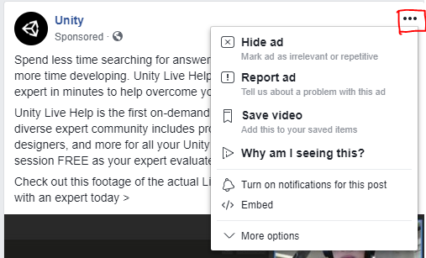 from Facebook

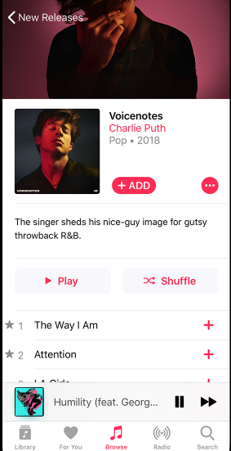 from iTunes

**Design pattern #5**  
**Name**: Share This icons  
**Description**: Within each of the logs’ more option icon, the user is given the option to share the log with friends and family via social media or message. By providing familiar social media icons and the message icon, this allows the user to easily recognize the platforms that the application supports. When an icon is selected, the user is directed to a new screen that will ask for further details on the what data he/she would like to share. In the Hi-Fidelity prototype the user can select at least 1 data (sharing all data is an option as well) from the log. What I didn’t show was the format of the shared data, but theoretically it would be modified to be easier to read and would include other relevant things like trends (if the user selects more than 1 data).   
For reference, I mainly use YouTube. In each of their videos, the platform provides “Share” button and allows the user to share directly to another user or a link to a social media platform.   
**Problem addressed and solution**: I don’t think that it is a problem that this design pattern addresses but more so a want from the user. To be able to share their results/log is a personal preference. For example, during the interview Suzanne would love to have an option to share the awesome results to friends and family who also shares may the same condition as her or is simply interested to see her good numbers. So this design pattern is for the users who would want to keep their trackings connected with others.   
**Link to example:** <https://www.youtube.com/watch?v=8u4rwiOqje4>  
**Images:**



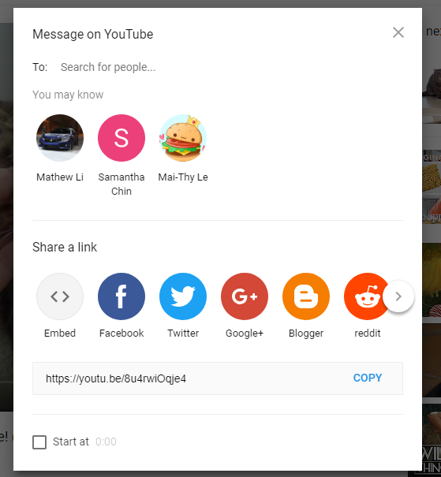 From YouTube

Summary

People diagnosed with different types of diabetes (Type 1, Type 2 and Gestational) are required to track different things on a daily basis, some of which includes blood sugar levels, carbs, intake of insulin, exercise, and diet; For these individuals, managing their condition can be a hassle. The constant need to take blood readings and document them alongside their meal habits is time consuming and can be easily forgotten without a reminder. Also, the numbers that the readings output can be very daunting and unmotivating for some individuals. We have identified 2 current systems, the first is the pen and paper method and the second is the existing apps made available on the market. The pen and paper method is simple, reliable and allows the user to keep track in any form that want; however, some of the disadvantages are error-prone, inefficient, can be easily lost, damaged, and requires a lot of storage space. The variety of apps provided for by the app store and/or google play store are very convenient for the users because the apps are on their mobile devices and they can input the data at any time. However, the disadvantages to this system is that some are too complex to learn or do not provide a lot of options. Another problem is that the screens within the apps can be too cluttered with data and buttons which can cause a lot of confusion when the user wants to complete a task. With a new and improved diabetes tracker, users diagnosed with a specific type of diabetes will benefit by having functionalities that will make things more convenient and more meaningful.

The problems introduced by the 2 current systems are solved by presenting an app with familiar design patterns and UI elements to help diabetics navigate easily and manage their tracking easily with the use of a mobile device which can be used anywhere without any extra required materials. One of a design pattern that was chosen is the more option icon and this is used to provide more options for the user to deal with the data and by click on the buttons presented the overlay the user is directed to a separate screen. This prevents the clutter within each of the logs and provides a convenient navigation. Another design pattern is the add new entry button located on the bottom right in the homepage. This also tackles the problem of the screen being too cluttered and confusing to understand because the button is isolated from the rest of the data on the homepage and persists with the screen as the user scrolls through the homepage.

There are 8 methods used to identify the system’s requirements which was introduced in part 2 of the proposal. These 8 methods are direct observation, indirect observation, survey, questionnaire, interview, focus group, product comparison and artefact collection. It is important to use more than one data source to ensure that the majority, if not all, of the system requirements are identified. This is because the system requirements are needed before creating the prototype which will represent the final design before the application is created. Creating the prototype is important because it is a visual representation of the application and is used as a baseline for the programmers. On a business standpoint, it is used to prove the improvements of the new system that will grab the attention of diabetics which can be used to compete with other apps currently on the market. It is the designer’s job to take the user’s goals, needs and wants into account while creating the prototype. The creation of the prototype is important because it allows others to easily understand the importance of each of the screen to the user, the relationship of each of the screens and the main flow of the application. The next step in the development process would be passing the prototype to the developers/programmers to create the actual application.

**References**  
<https://www.mockplus.com/blog/post/basic-uiux-design-concept-difference-between-wireframe-prototype>

<https://blog.prototypr.io/high-fidelity-prototyping-what-when-why-and-how-f5bbde6a7fd4>